Software engineering for big data analaysis

CSA-1035

EXP NO: 4

8. Make an Online Airline Reservation System. The activities of the Online Airline Reservation system are listed below user, admin, LOGIN, MANAGE CLASSES, MANAGE WAITING LIST, MANAGE HOLDS, MANAGE DEADLINES, LOGOUT, using this has a step-by-step process draw a CLASS diagram Draw a Class diagram for Library Management System using CASE tools

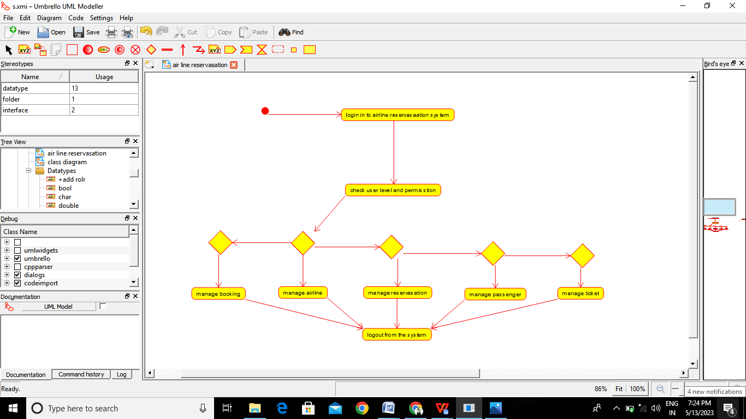

Result:-

Thus the use-case diagram for Hospital management is drawn and verified successfully.